Planning External Beam Radiation Therapy for Cancer Treatment
Shane Henderson (Cornell University)

Joint work with
Millie Chu, Yuriy Zinchenko, Cornell University
Michael B. Sharpe, Princess Margaret Hospital

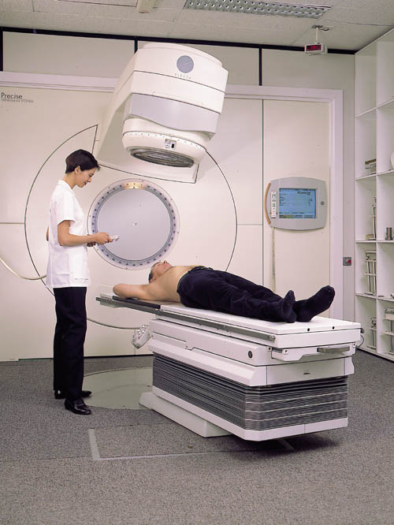
The radiation therapy treatment planning problem involves devising a radiation treatment plan that delivers a sufficient dose to a target region containing the tumour while sparing, as much as possible, surrounding organs. Traditional treatment planning models handle uncertainties arising from organ motion etc. by inflating the target region. We instead use a probabilistic model and show that it is equivalent to using robust linear programming. For a sample prostate case, our results show that the method is computationally feasible, and finds plans that are adept at sparing healthy tissue while maintaining the prescribed dose. I’ll discuss radiation therapy, the idea behind robust linear programming, our formulation and results. No prior knowledge of radiation therapy, cancer or robust linear programming is assumed.

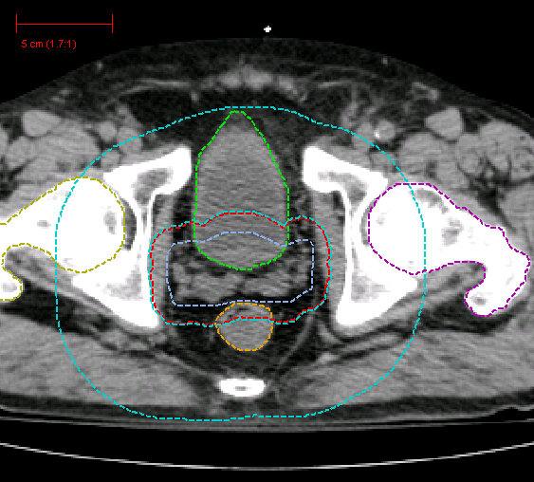
Bio: Shane G. Henderson is an associate professor in the School of Operations Research and Industrial Engineering at Cornell University. He has previously held appointments at the University of Michigan Ann Arbor and the University of Auckland in New Zealand. His research interests center on simulation, simulation optimization, and applied probability. He has many years of experience working in planning for emergency services, and maintains an interest in a variety of other application areas including yacht match racing, call center management and health care in general.

